**Survey Questions**

**Group 1: General Intelligence Questions (no constraints) 2 possible orders**

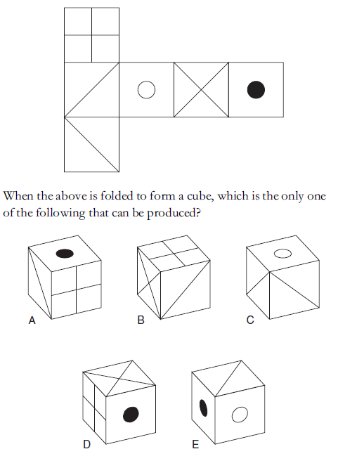

Correct Answer: A

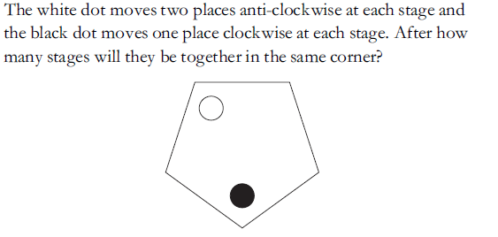

Possible Answers: 1 2 3 4 5

Correct Answer: 4

**Group 2: Survey Questions on Math (1 constraint) 12 possible orders**

1. (Easy) Luis turns 36 years old today. His age is 9 times that of his cat. His dog’s age is three halves the age of his cat. What is the sum of the ages of the cat and the dog?

Possible Answers: 8 9 10 12 13

Correct Answer: 10

1. (Medium) Ferb has constructed the following figure and, once done, has painted it blue without lifting it off the ground. How many of the cubes have exactly three faces painted blue?

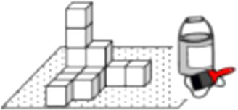

Possible Answers: None One Two Three Four

Correct Answer: Three

1. (Medium) What color was the paintbrush handle in the problem about the painted blocks?

Possible Answers: (a) Blue (b) Red (c) Green (d) Yellow (e) The picture was entirely black and white.

Correct Answer: (b)

1. (Difficult) If we increase the length of all sides of a square by a fixed percentage, its area increases by 96%. By what percentage would the area have decreased if instead of increasing the sides, we decreased the sides by the same percentage?

Possible Answers: 4% 64% 94% 48% 36%

Correct Answer: 64%